Document to capture all discussions and decisions:

What is NEO insights application for?

On a very conceptual level:

NEO insights is basically below two blocks

Processing

Data

Data:

It can be different types of CAD files OR

It can be different types of CT volumetric data like uint16_svc, .txm,.bin,.raw,.zxo etc

Processing:

This comprises of all the operations we perform on the data.

Doing metrological operations and visualization of Data all comes under processing.

We have below scenarios for NEO insights in metrology and defect analysis:

1. Inline/At-Line manufacturing – Would always require proper visualization of volume
2. Offline manufacturing – Does not requires visualization of volume

Both needs InspectionPlan and measurements.

In any type of measurement there is always a “Refrence part” and “Measured Part”

Most of the times reference part is CAD but it can be CT volumetric data also.

Measured part is always CT volumetric part.

Both reference part and measured part require following things:

1. Mesh Data (Surface mesh) Surface PointCloud and its connections to make a mesh
2. Volumetric information (even for CAD), like actual volume data pointer, width, height, depth etc.

For visualization purposes (except CAD) every CT volume data must get converted to visualization specific data structure (same CT data, but more optimized for visualization purposes, like Tiled data with various resolutions). In NEO insights it is “.zxo” format.

Hence for Inline/Atline applications we need to perform below step:

CT volume Data -> Parse CT Volume data (Different parsers would exists as per CT volume data) -> Convert the CT volume data into visualization format “.zxo” -> Make CT volume data structure which would be used in application

For Offline step this conversion is not required. Only parsing the CT volume data

CT volume Data -> Parse CT Volume data (Different parsers would exists as per CT volume data) -> Make CT volume data structure which would be used in application

Also one need to consider that Inline application mode would require a GUI, whereas Offline mode would not require and GUI at all!! Offline would be series of measurements steps which would run one after another without GUI.

This also means that … all lower layer data processing must be accessible through APIs.

This also should include metrological measurement APIs (Framewrok ?)

This means GUI in NEO insights application is optional. However for offline its mandatory.

NEO insights is going to use the existing EOS framework. Hence below are its constraints on application design:

WPF GUI application

Area wise registration of views and view controllers/ classes and abstracted MEF export/import

InspectionPlan task design to be followed.

CT volume data must be treated as an extension in InspectionPlan

Application design then must get composed of following layers:

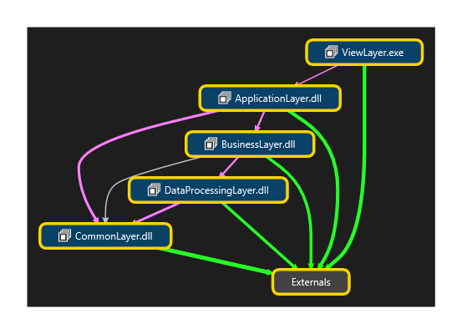

ViewLayer : All views (GUI) MainView are here

ApplicationLayer : All viewmodels are here.

BusinessLayer : Business logic classes are here. All business rules are here.

DataProcessing Layer : All data processing logic is here.

Common: All cross cutting concerns and classes for them resides here.